Chapter4
- Given a triangle with the following coordinates for its vertices: A(3,1), B(1,3), and C(3,3), rotate it by 90° about an axis passing through point P(2,2) and determine the new coordinate for A, B, and C.
- Show that a circle, when subject to the transformation given by matrix
does not remain a circle. What is the transformed shape?
- Magnify the triangle given in Exercise 1 to twice its size while maintaining point C in its original position. Calculation the transformed coordinates of the three points.
- Derive the appropriate matrix for reflection about a line given in slope-intercept form, where the slop is m and the y intercept is (0,c).
- A circle is defined by the equation
Find its equation in terms of X,Y coordinates, assuming that in the x1,y1 coordinate system is equal to , and is equal to . Does the circle remain a circle?
- Write the series of transformation (in matrix form) that are needed to place the square shown in Figure 4.13, reduce to half its size, into the position shown in Figure 4.14, where the center of the square is at (2,-2).
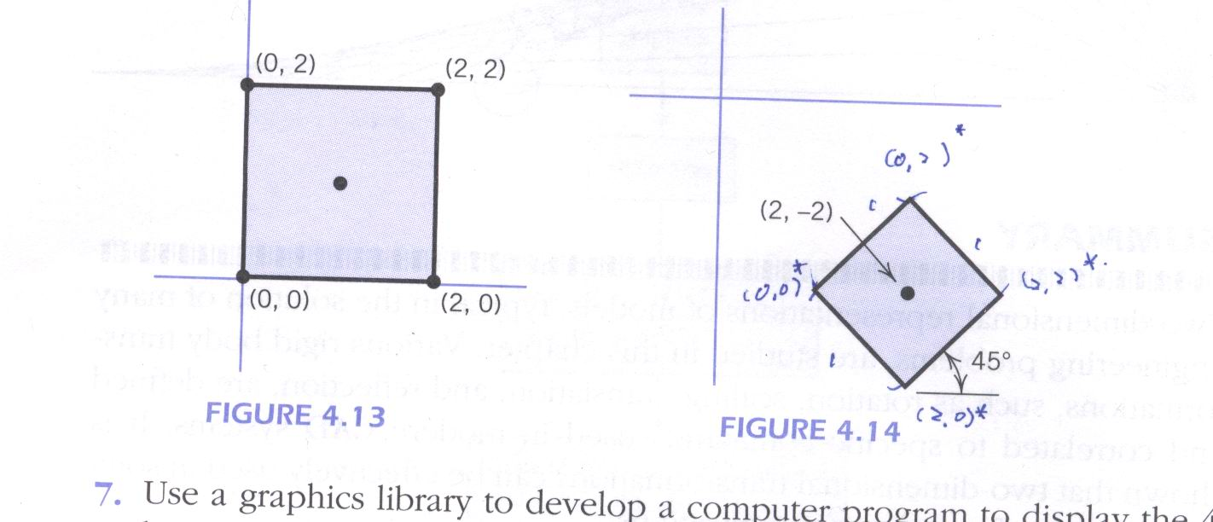

- Use a graphics library to develop a computer program to display the 4-bar mechanism shown in Figure 4.7, Varying from 0° to 360°, by increments of 30°. Solve the same problem using an interactive CAD system.
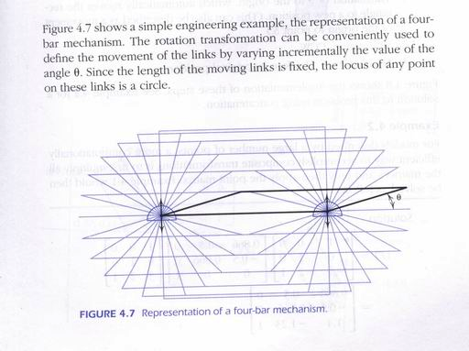
- Develop a computer program to implement the Mohr’s circle shown in Figure 4.11. Draw the two-dimensional stressed element in its original and rotated positions, including the stress vectors. Experiment with a CAD system to find stresses at any plane by using the Mohr’s circle.
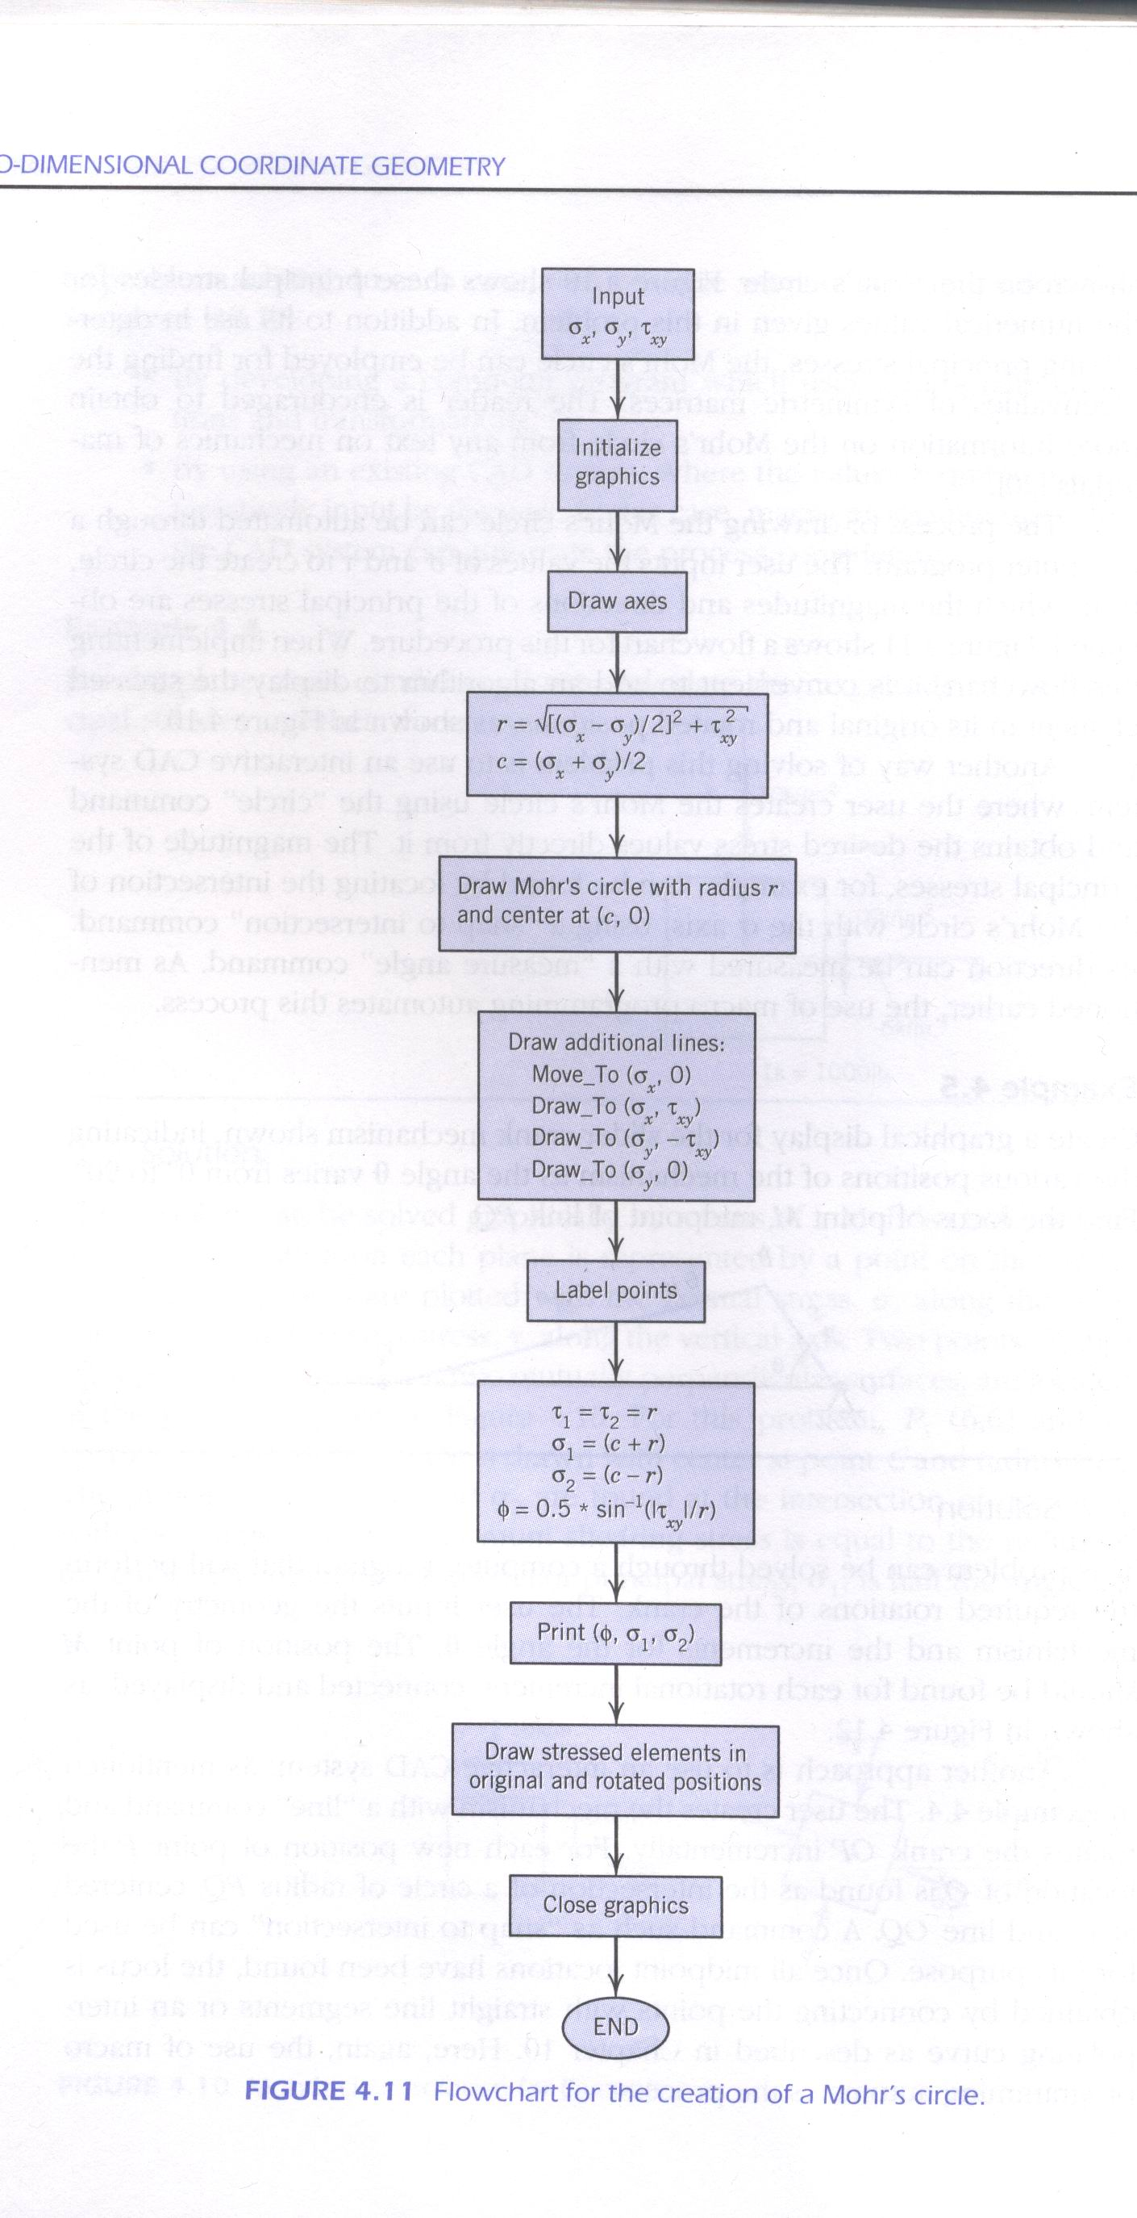

- Implement an algorithm to output Figure 4.12. The user input should be the geometry of the mechanism and the angular increment. Use a CAD system to solve the same problem, for the specific values given in Example 4.5.
