CH5 Exercise
- Use a series of transformations in matrix form ( translation, scaling, translation ) to derive the window-to-viewport-mapping relationships, also known as the normalization transformation.
- Find the normalization transformation matrix which maps the rectangle A (1, 0),
B (4, 3), C (3, 4), D (0, 1) to the normalized viewport shown in the accompanying figure.
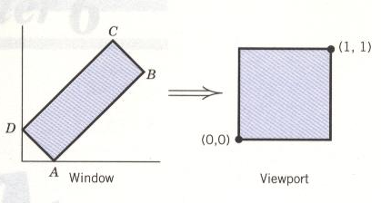
3. Suppose a window is defined as (-20, 20), (60, 60) in the world coordinate system. Consider a line segment whose two endpoints are given by (-30, 0) and (80, 40) and
(a) Determine the logical AND of the endpoint bit codes.
(b) Find the intersection if the line segment with the appropriate window boundaries.
(c) Assume that a viewport is defined by (10, 30) and (200, 130). Find the viewport coordinates for the intersection points.
4. In Problem 3, will the window size compared to the viewport size produce any distortions on the image of objects? Explain your answer.
5. A window is defined by the coordinates of its lower left corner (2, 2) and upper right corner (6, 8). A line segment from A(3, 1) to B(7, 5)is to be clipped against it. Find the endpoint codes of the line segment and their bitwise logical AND> Calculate the points of intersection of the line against the window boundaries, if any, by the midpoint subdivision method.
6. Establish the equation that will transform the area of a geographical map covering four square miles into a normalized viewport (0, 0) to (1, 1).

