CH6 Exercise
- Rotate the straight line joining A(1, 1, 1) and B(4, 3, 2) about the x axis and about the y axis, both in a counterclockwise direction. Repeat the process in the reverse order, rotation about y followed by rotation about x, and compare the final coordinates of the line.
- Consider the cube shown in the accompanying figure, with sides of length 4 in. Rotate the cube by an angle of CCW about the diagonal OA. Knowing that point E is the midpoint of AB, find the coordinates of E, B, and C before and the rotation.
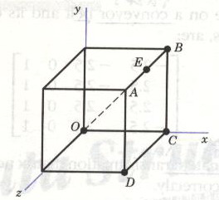
- Prove that, given a line and its midpoint, the transformed midpoint will still be the midpoint of the transformed line.
- Three points in space are represented by A, B, C. Given three other points, Q, R, S, find the transformation matrices needed to
  - Transform A into Q.
  - Transform the plane of ABC into the plane of QRS.
- In the accompanying figure, use the orthogonality property of the rotation matrix to place triangle AOB on the xz plane.
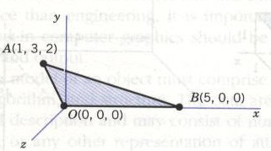
- Consider a rectangular box with its top side open, represented by the following coordinates:
A plate is available on a conveyor belt and its coordinates, when the conveyor belt stops, are:
Obtain the concatenated transformation matrix needed to place the plate on top of the box correctly.
- Any angle formed by two intersecting planes is called a dibedral angle. Calculate this angle for the two planes defined as follows:
Plane 1 (-1, 1, -1), (0, -1, -2), (4, 0, 2)
Plane 2 (-1, 1, 1), (4, -3, -1), (6, -1, 2)
- Rotate the point clockwise about the axis given by the points
and .
- Establish in matrix form the series of transformations needed to transform the unit cube shown in Figure 6.26(a) into the solid shown in Figure 6.26(b).
