CH8 Exercise
- A diametric projection is an axonometric projection with two of the three foreshortening factors equal and the third arbitrary. It is constructed by a rotation about the y axis by φ followed by a rotation about the x axis by θ and an orthographic projection. Knowing that the foreshortening factor along the z axis is , and that , find the angles φ and θ needed for a dimetric projection.
- Given the unit cube of the accompanying figure, rotate it about the y axis by , about the x axis by and perform a 1-point perspective projection onto the xy plane, with the center of projection at z =2.0. What kind of projection results from these transformations? Plot your results.
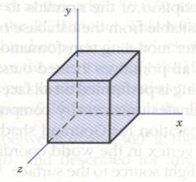
- The unit cube of Exercise 2 is translated by five units in the negative z direction, and a cavalier projection is obtained with an angle of inclination of . Calculate the final coordinates of the projection and sketch the view.
- Use a graphics library to implement the four steps described in association with Figure 8.11. Any set of valued that maintains the proportions of the object can be used to create the geometric data structure.
- For the object in Figure 8.34, establish the viewing parameters to obtain the following:
  - An orthographic side view
  - A one-point perspective with center of projection along the z axis
- Check the viewing parameters needed for the graphics library available to you, and find their default values. Use these parameters to output the views stated in Exercise 5 (Figure 8.34).

