CH9 Exercise
- For the unit cube shown in the accompanying figure, find the visibility of all faces when viewed from a point V(0.5, 0.5, 2.0).
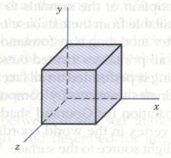
- Consider a plane defined by A(1, 0, 1), B(4, 0, 1), C(2, 4, 2). If it were to undergo a minimax test, what would be dimensions of the bounding box? Run a minimax test to check the visibility of this plane against another defined by D(3, 0, 2), E(2, 0, 0) and F(1, 6, 0).
- Given the polygons:
ABCD: , , ,
PQRS: , , ,
Run a check for possible containment.
- A surface is defined by three points, A(1, 0, 1), B(1, 0, 0), and C(1, 1, 1). An illumination source is located at a large distance from this surface in the direction . Determine the intensity of light necessary at this light source if the shaded intensity for the surface is to be set at 2. The reflectivity of the surface is 0.3.
- For the rectangular plane defined by points and , find the reflected intensity at point P(0.5, 0.5) using the Gouraud shading technique. The average intensities of reflected illumination at the four vertices are:
- Check your graphics library for availability of hidden line/surface removal procedures and shading. What are the specific algorithms used?

